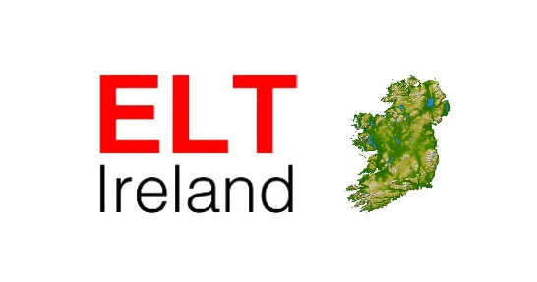

ELT Ireland Annual Conference 2016 | Call for Papers

21st & 22nd of February, 2016.

Call for papers for the ELT Ireland Conference: “Quality for all in ELT from young learners to older adults ” is now open. The focus of the conference is to host practical and theoretical presentations which can help to enhance our classroom experiences and aid our understanding of new developments in ELT.

Talks should be 40 minutes with 10 minutes for questions and answers. More than one presenter is welcome.

We are looking forward to contributions from all involved in the ELT sector with public or private institutions.

Important dates to remember:

- 23 September 2015 Call for proposals opens
- 30 October 2015 Call for proposals closes
- 20 November 2015 Acceptance notifications & Publications of talks conference
- 30 December 2015 Speaker registration closes

Please email ELT Ireland at info.eltireland@gmail.com for a proposal submission form.

Speaker One:

Name (First Name, Family Name):
Title (highlight one): Mr Mrs Ms Prof Dr Other:
Position (e.g. teacher, teacher trainer, director of studies, director, researcher):
Home/Contact address
Street: Number:
City: Postal Code: Country:
Telephone (include country/city code): Mobile:
Email:

Institutional Affiliation & Address
Name:
Street: Number:
City: Postal Code: Country:
Telephone (include country/city code): Fax:

Speaker Two:

Name (First Name, Family Name):
Title: Mr Mrs Ms Prof Dr Other:
Position (e.g. teacher, teacher trainer, director of studies, director, researcher):
Home/Contact address
Street: Number:
City: Postal Code: Country:
Telephone (include country/city code): Mobile:
Email:
Institutional Affiliation & Address
Name:
Street: Number:
City: Postal Code: Country:
Telephone (include country/city code): Fax:

NOTE: If there are three or more speakers, please add their information at the end of this form.

Title of presentation (not more than 10 words):

Summary of presentation (maximum 100 words)

Presenter’s (or presenters’) bio for inclusion in the programme (maximum 60 words):

NOTE: All rooms come with a desktop computer, a data projector, a whiteboard and a WiFi connection.

Please note that you will have to bring enough copies of the hand outs for the workshop/talk. You should plan on 30 participants.

